**Dual Access Control for Cloud-Based Data Storage and Sharing**

**Objective:**

The main aim of this project is to provide dual access control for cloud based data storage and sharing. Also provide a privacy and security for files sharing and storing.

**Project flow:**

The flow for the project is given below:

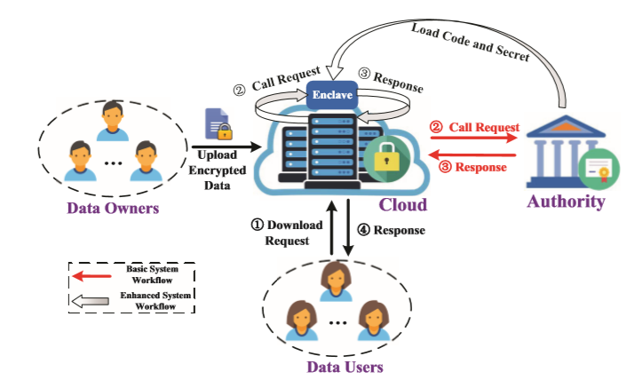

**Advantages of Project:**

* It takes less time to collect a data file’s.
* It provides move security on data.

**SYSTEM SPECIFICATIONS:**

# **H/W CONFIGURATION:**

# **Processor - I3/Intel Processor**

1. Hard Disk -160GB
2. Key Board - Standard Windows Keyboard
3. Mouse - Two or Three Button Mouse
4. Monitor - SVGA

**S/W CONFIGURATION:**

* Operating System : Windows 7/8/10
* IDE : Pycharm
* Server side scripts : HTML, CSS, Js
* Libraries Used : Pandas, smtplib, Flask
* Technology : Python 3.6+